contour rack - STANDARD

2010+ Crew/Mega cab

Installation guide
TOOLS:
- 9/16” socket
- 3/4” socket
- 3/16” Allen Key (included)
- 3/16” Hand Driver (included)
- 7/32” Allen Key
- 5/16” Allen Key
- T-25 Torx driver
- Drill
- 3/8” drill bit
- 1/2” drill bit
- Carpenter’s Square

Notes
- This Rack is designed to be installed on Standard Bed (Non-RamBox) equipped Ram trucks with the Crew Cab or Mega Cab.
- Many of the included fasteners are stainless steel. Anti-Seize has been included with your hardware to protect the threads of the stainless fasteners. Use it! By their nature they have the potential to gall or seize during tightening if they are damaged or if dust or other material becomes lodged between the threads of the bolt and nut. If during tightening a fastener becomes rough while turning or otherwise feels like it is seizing, STOP. Spray penetrating lubricant into the nut, remove the nut and throw both nut and fastener away. Applying anti-seize to the threads goes a long way to preventing this!

hardware

RACK HARDWARE: (included)
- Bolts
  - 5/16”-24 Stainless Button-Head Cap Screws (3/16” Allen drive)
    - 5/8”, Qty: 8 + spares
  - 3/8”-16 Stainless Button-Head Cap Screws (7/32” Allen drive)
    - 1-1/2”, Qty: 2 + spares
  - ½”-13 Stainless Button-Head Cap Screws (5/16” Allen drive)
    - 1-3/4”, Qty: 2 + spares
  - ½”-13 Stainless Button-Head Cap Screws (5/16” Allen drive)
    - 1-1/4”, Qty: 6 + spares
- Nuts
  - 3/8”-16 Stainless Flanged Nylon Locknuts (9/16” socket drive)
    - Qty: 2 + spares
  - ½”-13 Flanged Locknut (3/4” socket drive)
    - Qty: 2 + spares
  - ½”-13 Nut Plates
    - Qty: 8
- Washers
  - 3/8” Stainless Washers
    - Qty: 2 + spares
  - ½” Stainless Washers
    - Qty: 12 + spares
  - 5/16” Stainless Washers
    - Qty: 8
- Loctite 242 Blue
- Loctite Anti-Seize

CROSSBAR HARDWARE: (included)
- ¼”-28 ArmorCoat Screws
  - 3/4", Qty: 28 + spares
- Loctite 242 Blue

Installation
- Using a T-25 Torx driver, remove the screws holding the tail lights in. Remove the tail lights by pulling them STRAIGHT BACK, parallel to the truck. You can disconnect the tail lights or leave them connected and tuck the lights under the tailgate cables.

- Cut out the plastic surrounding the stake pockets at the four corners of the bed rail. The pockets are marked with a line around the perimeter of the pockets – cut on this line.
`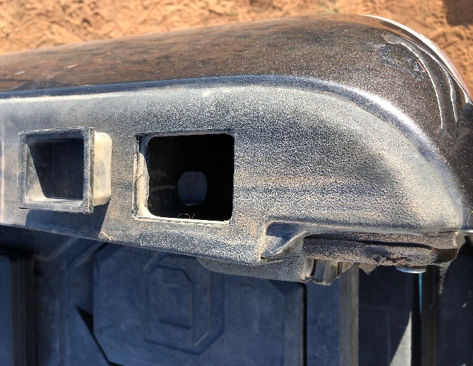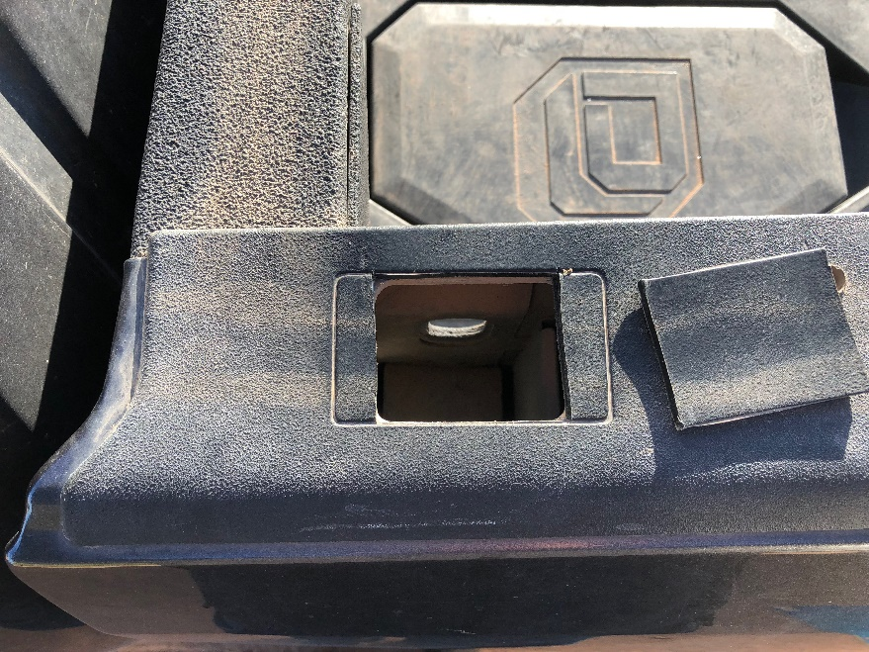

- Assemble the front mounting brackets onto the front hoop. Using the 8 5/16”-24 x 5/8” stainless bolts and matching washers, assemble the mounting plates onto the front hoop. Loctite 242 Blue these fasteners.
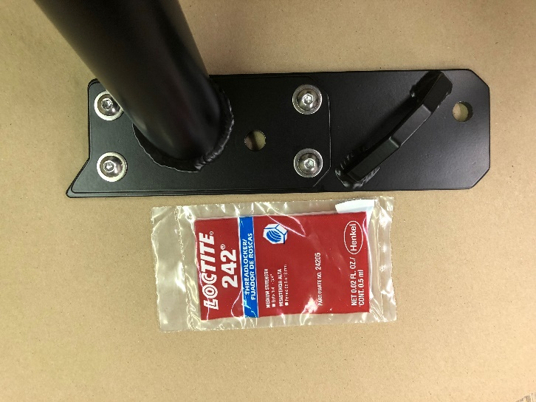

- Using the two Nut Plates (the powder coated plates with nuts welded into them) and two 1/2"-13 x 1.75” Button Head screws with washers: Apply Loctite to the screw and insert the screw through the forward hole of the rack mounting plate from the top and thread it partially into the nut plate. Make sure the nut plate has its flat surface facing up. Loctite 242 Blue these fasteners
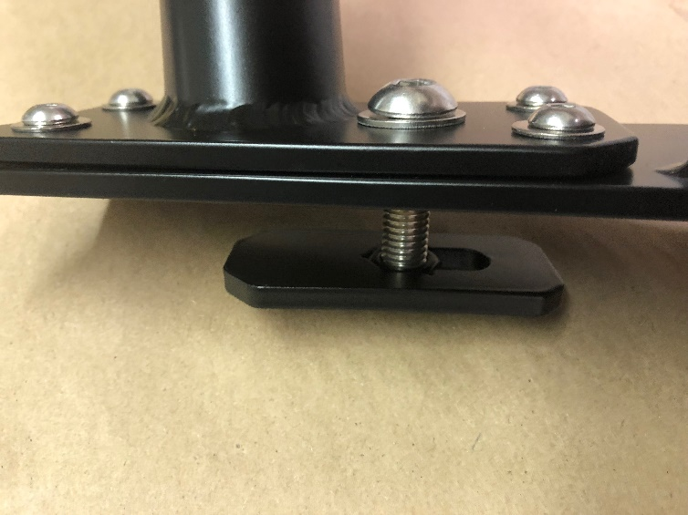

- With both nut plates hanging free from the front hoop assembly, maneuver the assembly onto the truck, sliding the nut plates into the stake pockets.

- Taking the side rails and their separate clamshell clamps (6-bolt clamps), insert the side rail pocket assemblies into the rear stake pockets, and loosely assemble the side rails onto the front hoop using the clamshells and necessary hardware. The front clamp of the side rails should sit against the front hoop at a certain height: measure 13” up from the top of the mounting bracket to the base of the side rail tube – this is the approximate height of assembly.
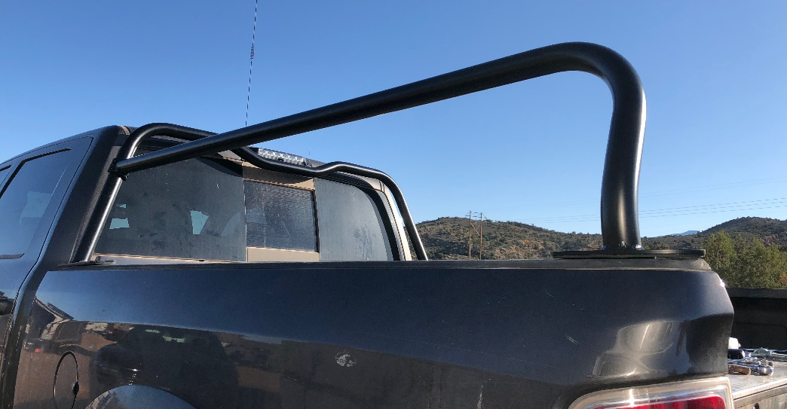

- Once both side rails are roughly assembled onto the front hoop, install both crossbars – one at the front of the side rails, one at the rear. The crossbars are used to fix the width of the side rails when installed. Install the hardware into the crossbar clamps and just make them finger tight, these should still allow some movement of the tubes.

- Once crossbars are installed onto the side rails, ensure the connection between the side rails and the front hoop is correct. You may need to loosen the front clamshell clamps and adjust the height of the side rails on the front hoop. Because of the angle of the front hoops’ legs, adjusting the side rails up/down on the front hoop will also adjust the width between the side rails. Find the height that makes the width work best with the crossbars. Once the best height is found, tighten the crossbar clamps and then the side rail to front hoop clamps to being hand tight.

- Using the 1/2"-13 x 1-1/4” button head bolts with washers and a set of nut plates, install this hardware through the bed support into the rear stake assembly and tighten down. Torque to 80ftlb. Anti-seize these fasteners.
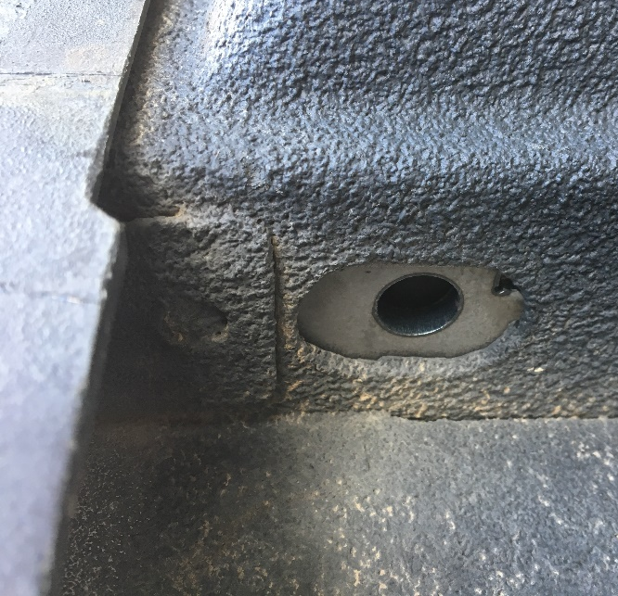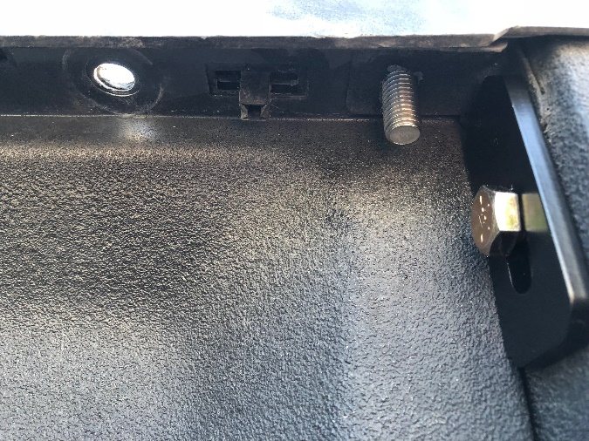

- Tighten the bolts in the front hoop mounting plates. The nut plates previously installed here will rotate and then engage the inner sides of the stake pocket and can be tightened. You may need to hold the plates down to keep the nut plate from pushing back against you. If the bolt starts to tilt during tightening, back it out 1/4 turn to straighten the assembly and then continue to tighten. Tighten to 60ftlb or less.

- Now that the assembly is fixed in place, three holes per side will need to be drilled down through the bed rail. For the front brackets there is one 1/2” hole. The rear brackets have one 1/2" hole and one 3/8” hole to drill.
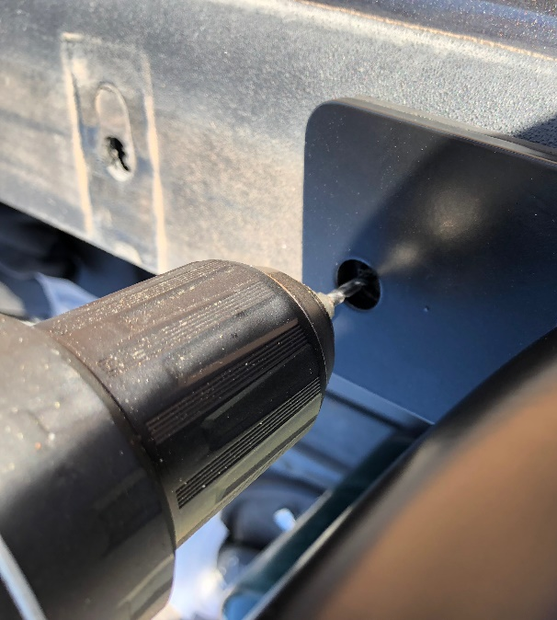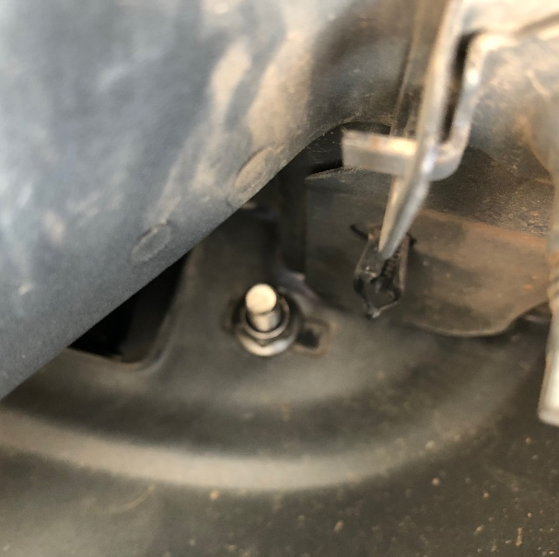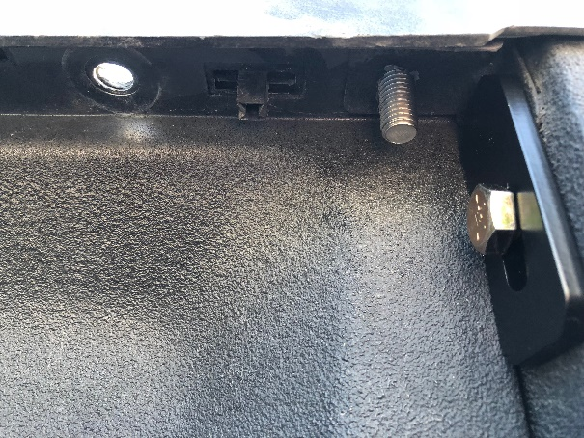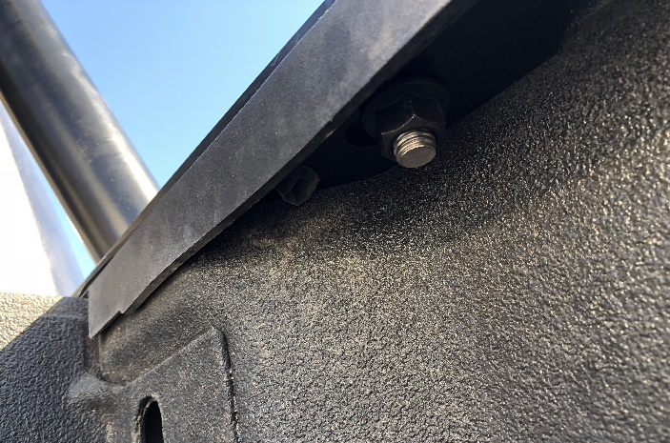

- Once all holes are drilled, install the final 1/2"-13 x 1-1/4” button head bolts with washers and the 1/2"-13 flanged locknuts and 1/2”-13 nut plates through these holes. Install the very rear 3/8” hole using the 3/8”-16 x 1.5” button head bolts and the flanged locknut. Anti-seize these fasteners.
- The final step is to permanently install the side rail clamshells. One-by-one, remove each screw, apply Loctite 242 Blue, and then re-install the screw, tightening it to about 10ftlb with the included L-key.

- Your rack is now installed! You can remove the crossbars and place them wherever you need along the rack. They should fall in place easily – if the width of the rails seems to narrow or wide, make the necessary adjustments to either the rear stake mounting or to the front clamshell connection.

IMPORTANT!: When clamping the crossbars down, you MUST understand that the clamping force developed by these screws is massive with even the smallest torque applied to them. BE VERY CAREFUL when snugging these fasteners that you Loctite them and only snug them to JUST past the point of being finger snug. Really, 5-lb.ft. is generally enough. The friction between the surfaces combined with the very tight geometry of the assembly means that these crossbars really aren’t going to move, so DO NOT OVERTIGHTEN THE CLAMP BOLTS. For example, if you tighten these fasteners to only 10lbft you will develop almost 6,000 pounds of clamping force PER CLAMP!

NOTE: When installing screws into the clamps, make sure to thread them in evenly and to tighten them evenly to prevent ‘cocking’ the clamp.

If you have any questions or issues regarding installation, please text or call (909)-319-6352

