contour rack - rAMbOX

2019+ Ram 1500

Installation guide
TOOLS:
- 9/16” end wrench
- 9/16” socket & ratchet
- 7/32” Allen Key
- T-25 Torx driver
- 10mm Socket
- Carpenter’s Square or measuring tape
- 3/16” Allen Key (Included)
- 3/16” Screw-Retaining Hand Driver (Included)

Notes
- This Rack is designed to be installed on RamBox equipped Ram trucks with the Crew Cab or Mega Cab.
- Many of the included fasteners are stainless steel. By their nature they have the potential to gall or seize during tightening if they are damaged or if dust or other material becomes lodged between the threads of the bolt and nut. If during tightening a fastener becomes rough while turning or otherwise feels like it is seizing, STOP. Spray penetrating lubricant into the nut, remove the nut and throw both nut and fastener away. Use new hardware.
- If you have any questions or issues regarding installation, please text or call (909)-319-6352

Hardware

Rack Hardware: (Included)
- Bolts
  - 3/8”-16 Stainless Button-Head Cap Screws (7/32” Allen drive)
    - 1-1/2”, Qty: 12 + spares
- Nuts
  - 3/8”-16 Stainless Flanged Nylon Locknuts (9/16” wrench drive)
    - Qty: 12 + spares
- Washers
  - 3/8” Stainless Washers
    - Qty: 12 + spares

Crossbar Hardware: (Included)
- Bolts
  - 1/4"-28 ArmorCoat Socket-Head Cap Screws (3/16” Allen drive)
    - 3/4", Qty: 28 + spares
- Loctite 242/243 Blue

Installation
Pre-Install: Empty all contents of both RamBoxes.

- Unscrew the plastic uprights next to the tailgate opening. Using a T-25 Torx driver, remove the screws holding the tail lights in. Remove the push-clips retaining the tail lights, next to the screws. These have a center section that pops out and is easiest to remove with a trim tool or screwdriver. Remove the tail lights by pulling them STRAIGHT BACK, parallel to the truck. Disconnect the tail light electrical plugs and place the tail lights somewhere safe.
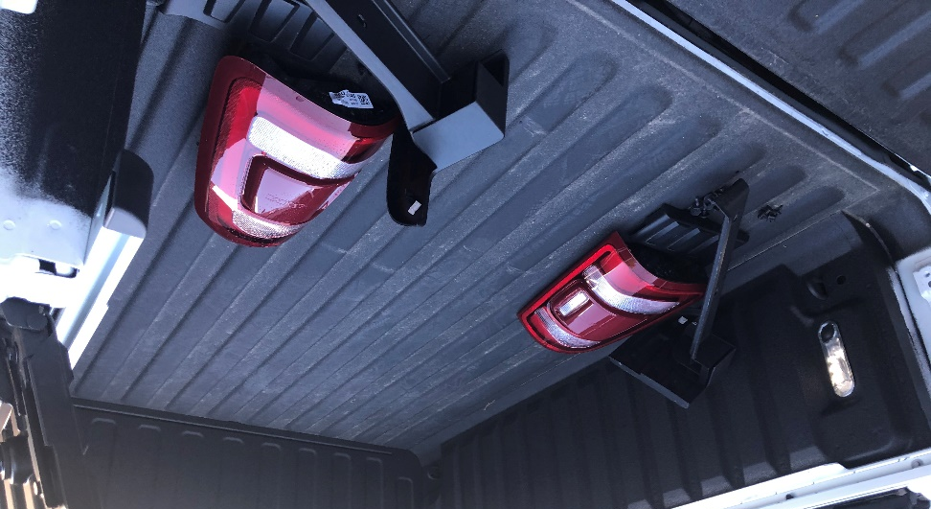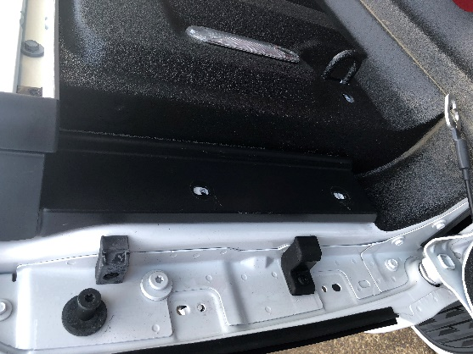

- Using an 8mm socket, remove all screws inside the RamBoxes including the two screws through the lid latch. Remove the screws that bolt through the RamBox hinges (do not remove the adjustable rubber bumpers). Disconnect the electrical connector that plugs into the RamBox. This connector is easiest to see through the tail light opening, and easiest to remove by reaching up under the bed. Lift the RamBox straight up to remove it from the truck. Lay the RamBox gently on its back on a moving blanket or tarp as they tip over easily. The RamBoxes can tend to stick - pulling up on the steel latch in the center and wiggling the box tends to make removal easiest.
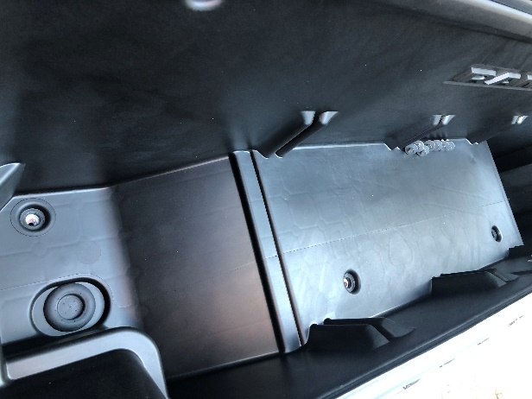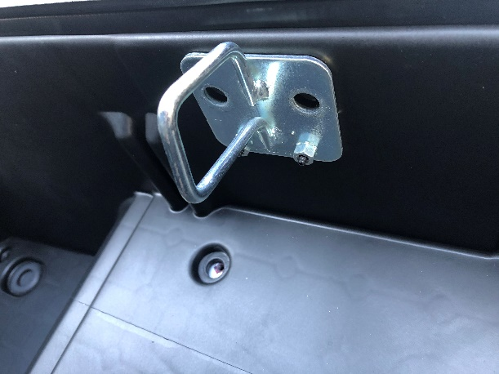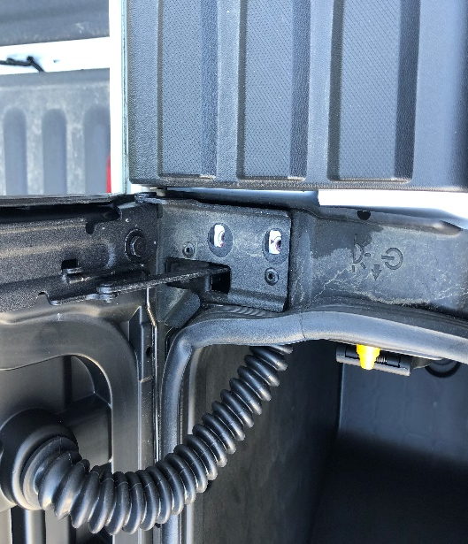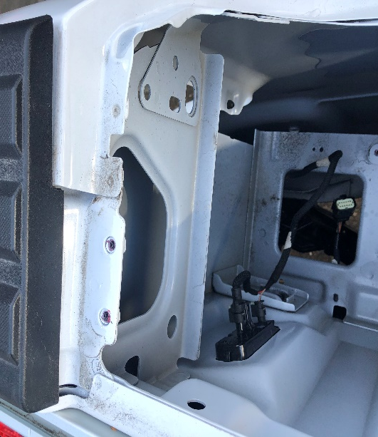

- Remove the plastic top caps at the four corners of the bed (the rear caps attach to the plastic uprights). These will be replaced by the mounting pads on the rack. If you wish to keep these caps, use trim tools and be careful as they commonly break during removal. If you do not need these again feel free to pry them off and break the plastic tabs on them.

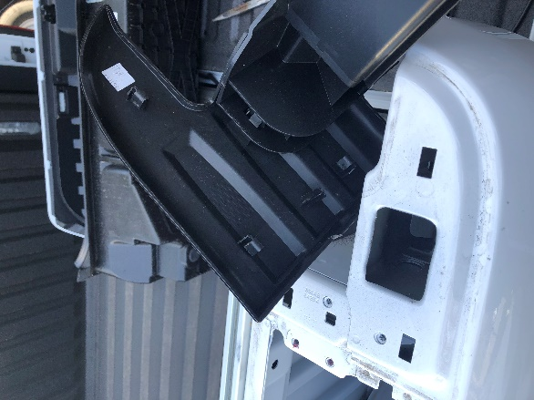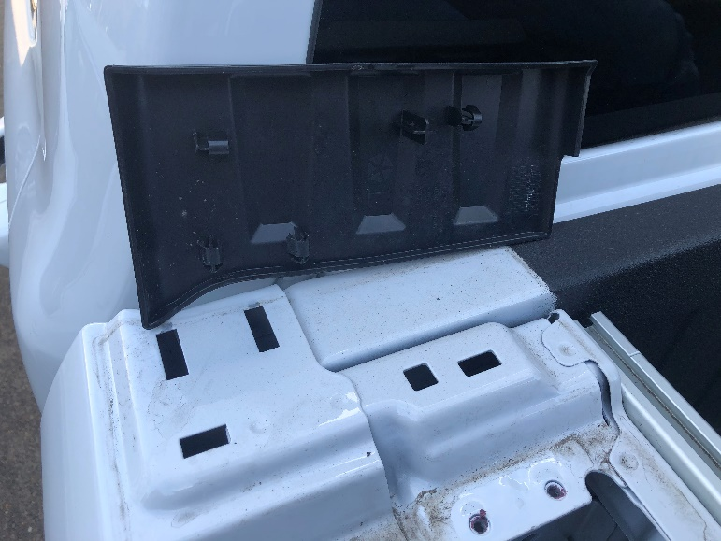

- If a small support plate is present under the plastic caps on the rear of the bed, remove them. The rack will now perform their function.
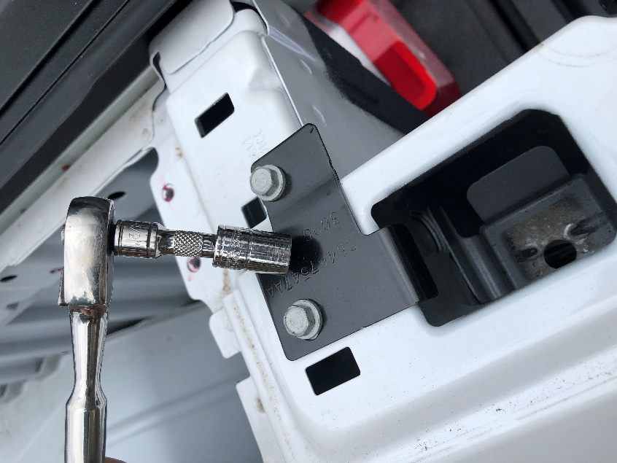

- Place the front hoop of the rack (the portion that contours to the cab of the truck) onto the corner pads where it will bolt down. Apply anti-seize to the threads of the bolts, and install the bolts and washers from the top through the mounting pad and into the truck bed and thread the nuts on from underneath. [DO NOT get anti-seize on you or your clothes – it is a permanent addition to clothing – wipe off your hands or parts with a rag immediately if there is excess]. Access to the front bolts will be through the RamBox opening. Check that the gap between the front hoop and the cab and rear glass is at a healthy distance. The cab is mounted on hydraulic body mounts that allow the cab to float on the frame – the rack should have at least 3/4” gap or more from the cab. Torque these fasteners to 20ftlb.

- Set the side rails in place, and hold them as you drop the bolts through the mounting holes of the rear base plate. You can usually rest the side rail against the front hoop by setting the tube clamp against the front hoop. Use a carpenter’s square or a tape to measure from the top of the front mounting pads up 13-1/4”. This is the approximate distance the side rails should sit above the mounting plates. Raise the side rails to this distance and loosely install the clamps with their hardware.
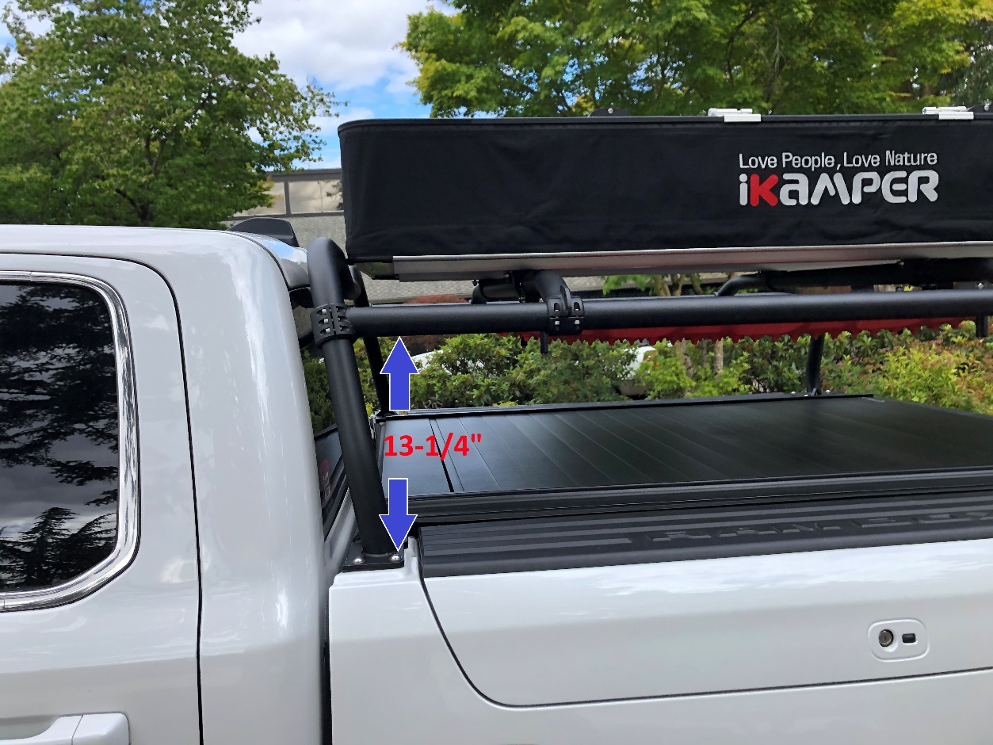
- Place the crossbars on the side rails, one towards the front and one towards the rear. Loosely install the clamps onto the crossbars with the provided hardware. If the side rails seem too close or too far from each other to properly install the crossbars, loosen the front clamps that mount to the front hoop and raise or lower the side rails on the front hoop. Raising them narrows the distance, lowering them widens the distance. Once the distance is set correctly you can snug down the crossbar clamps and give one more test by loosening the side rail clamps again and raising/lowering the side rails, finally tightening them where you feel the least resistance. Remove each screw in the side rail clamps one at a time, Loctite them, and put them back in. Use Loctite 242 Blue. Torque these screws to 8ftlb.

- Now reposition the rear base plates if necessary to align them to the bed, and tighten all fasteners. Access to the rear bolts will be through the tail light opening and through the RamBox opening. Torque these fasteners to 20ftlb.
- Installation is now complete! Install the RamBoxes just as they came out. Remember to connect the electrical plug underneath the bed for your RamBox interior lights. Install tail lights just as they came out. Test the RamBoxes to ensure that when the lid is opened it does not hit the rack.

IMPORTANT!: When tightening the clamp screws, you must understand that the clamping force developed by these screws is huge with even the smallest torque applied to them. Loctite is provided for the side rail to hoop clamps, but is optional to use on the crossbars, depending on if you plan to frequently remove them or leave them in place for long periods. Be careful when snugging these fasteners that you only snug them to JUST past the point of being finger snug. Really, 5-lb.ft. is generally enough. The friction between the surfaces combined with the very tight geometry of the assembly means that these crossbars really aren’t going to move, so do not overtighten the clamp bolts. For example, if you tighten these fasteners to only 10lbft you will develop almost 6,000 pounds of clamping force per clamp!

NOTE: When installing screws into the clamps, make sure to thread them in evenly and to tighten them evenly to prevent ‘cocking’ the clamp.

