INTERCOOLER GUARD

2019+ Ram 2500/3500

tools
- 10mm Socket
- Socket Swivel Adapter (U-joint)
- Socket Extension
- Inch-Pound Torque Wrench

Hardware
- Bolts
  - M6x16mm Flange Head Bolts (10mm drive)
    - Qty: 4

Notes
- This guard is designed to be installed onto the factory intercooler. It is not designed for aftermarket intercoolers. The factory assembly integrates an air scoop attached to the intercooler and an air dam on the front bumper. The air scoop at a minimum needs to be removed to install this part.
- If you have any questions or issues regarding installation, please email tech@dethloffmfg.com or text or call (909)-319-6352

indemnification
Buyer hereby acknowledges that driving both on and off road are dangerous activities and that the products and/or supplies purchased from Dethloff Manufacturing, LLC are used in an inherently dangerous activity that may endanger life and limb; and in no event shall the seller, or seller’s heirs and assigns, be held liable for consequential damages, nor shall seller’s liability on any claim for damages arising out of or connected with the sale, delivery, installation or use of purchased products and/or supplies exceed the purchase price of the products and/or supplies.

Installation
Pre-Install: This guard is intended to be mounted once the factory intercooler air scoop is removed. This is normally done when the bumper air dam is also removed. *These components can be taken off by removing a series of fasteners and clips that secure the air dam to the bumper and the air scoop to the intercooler. The air scoop has a series of push clips at the bottom and two screws on each side where it bolts to the intercooler. Do not remove the plastic cowling on the back side of the intercooler that acts as a ducting shroud for the radiator fan to pull air through the radiator and intercooler, this is intended to stay in place and is important for cooling. Ensure your intercooler is clean of bugs, mud and debris and to check for any rock or branch damage to the fins.
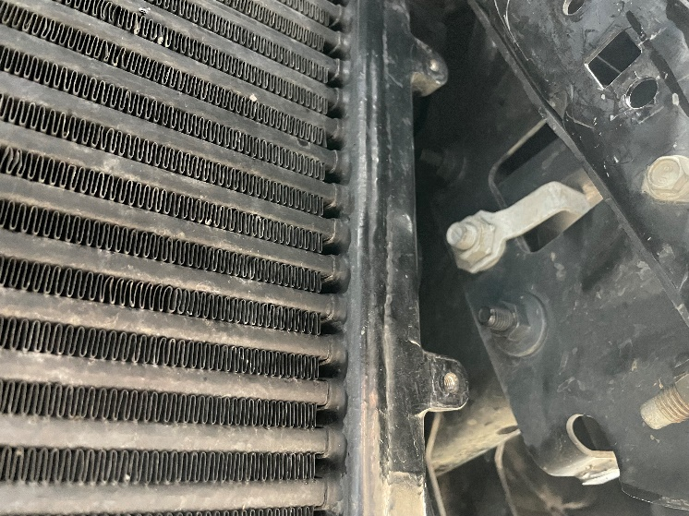
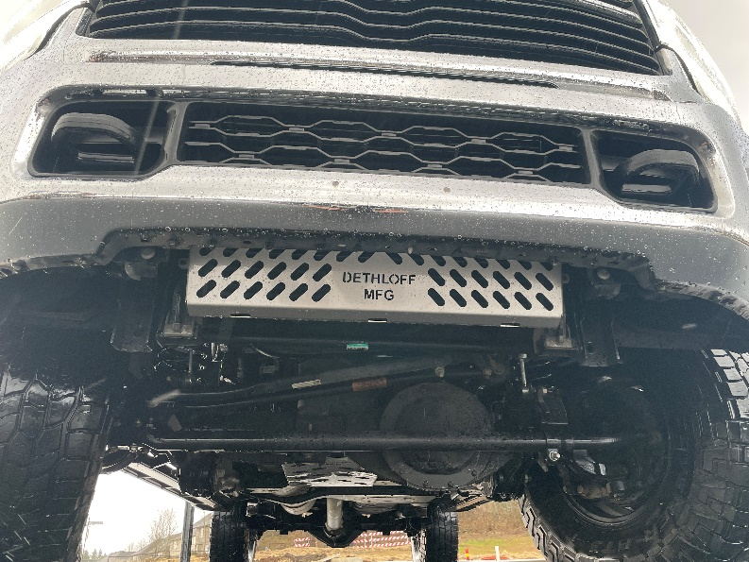
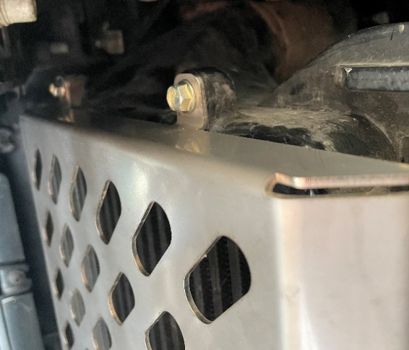
- Place the Intercooler Guard over the factory intercooler. Ensure there is no debris or errant factory welds preventing the Guard from sitting flush against the intercooler. There are four obvious mounting points on the surface of the intercooler that align with the four mounting points of the guard. Insert the included screws, and tighten to 108 in-lb.

